BRANDY BECKETT – “Mapping? Who Cares.”
Brandy began her career as a GIS Consultant with BlueLine Geo, LLC. in 2007, researching and developing GIS applications. This involved designing GIS business strategies and creating ArcGIS marketing tools for appointed oil & gas clients. For the next several years, Brandy worked as a contract GIS Analyst for Quicksilver Resources, Encana Oil & Gas, and Laredo Petroleum. During this time, she utilized ArcGIS and land asset management skills to include 2D & 3D land analysis, data integration, application integration, and coordinated these efforts across multiple disciplines in the industry. In 2014, Brandy left Laredo Petroleum as a Senior GIS Analyst to work as a GIS Specialist for her current employer Comstock Resources, Inc. Her duties include project management, web map development, GIS expansion and LMS integration with simultaneous GIS management of Comstock’s land asset base.
Brandy is always learning and teaching what she learns. From Bible Study and Sunday School to GIS Mapping 101, every day is a new opportunity to learn, share, and grow.
DEMETRI J. ECONOMOU - “Consent, Assign; Resent, Resign"
Demetri has over a decade of high-stakes oil and gas experience and currently co-chairs KRCL’s Energy, Oil & Gas Practice Group. Demetri is regularly on the front lines of disputes, both before and during litigation. With over 10 years advising general counsel and business leaders in the energy industry, Demetri brings the experience and resolve necessary to meet any legal challenge. He provides trusted advice to KRCL’s upstream, midstream and oilfield services clients, including in high-dollar royalty litigation and cases involving lease and deed interpretation, surface use, midstream and services contracts, and oilfield trade secrets, including both trial and appellate work. Demetri and the KRCL energy team regularly speak on cutting-edge energy law issues throughout Texas.
In support of KRCL’s Chambers-ranked bankruptcy practice, Demetri advises oilfield equipment financiers and banks in preserving and enforcing multi-million-dollar security interests. He has been selected to the Super Lawyers Rising Stars list for the past six years, 2017-2022.
Demetri also represents energy and non-energy clients in restrictive covenant and unfair employment practices lawsuits. He has prosecuted and defended cases involving non-competition and non-solicitation covenants and allegations of misuse of confidential information and trade secrets. In support of KRCL’s Labor & Employment Practice, Demetri also assists select clients with employment counseling, including issues regarding onboarding and exiting employees, personnel agreements, compensation schemes, and core HR documents.
Demetri is a leader on KRCL’s Project Make-A-Difference Committee and the Firm’s 30 Acts of Giving Campaign, acting as liaison for KRCL’s support of bridge-employer programs for teens and young adults with autism and autism-spectrum disorders. This is a focus near and dear to his heart.

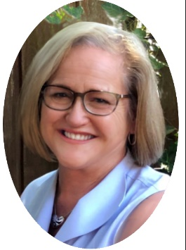
KATHRYN A. VERMILLION – “GOOD TITLE – Focus on the Cure”
Kathryn, known as “Katie”, has been a Professional Landman since 1980. She started as an independent landman in the field running title and obtaining curative in South Louisiana. Katie went on to work as a Landman and Partner at Park Oil & Gas, a private company in New Orleans specializing in producing property acquisitions in Louisiana, Texas, Colorado, and Offshore Gulf of Mexico. This involved a lot of due diligence title review and establishing land department procedures with a land records system for the growing company.
Katie earned her Certified Professional Landman Certificate (CPL) in 1983; and in 1984, she received AAPL’s Special Leadership Award for “Outstanding Accomplishment In Providing Incentives Towards Excellence In Others”. Katie also served on the Board of Directors for the Professional Landman Association of New Orleans (PLANO) from 1984-1987. Park Oil & Gas relocated their offices to Dallas, Texas in 1989, and by 1990, had sold all their properties. Katie then co-founded Vertex Oil & Gas in Dallas specializing in A&D. While at Vertex, Katie pursued a Master of Fine Arts in Painting at the Savannah College of Art & Design (SCAD). She would fly back to Dallas several times a month of help with property acquisitions.
Katie brought her oil and gas land background into her artwork. Using Tobin maps as inspiration she told visual stories about the people who worked the land. AAPL featured on of Katie’s mapworks on the cover of Landman Magazine, and one of her prints hangs in the Assessor’s Office of Plaquemines Parish, Louisiana. The U.S. Department of State selected another of Katie’s artworks to hang in the U.S. Embassy at Geneva, Switzerland from 1994 to 1998.
After the Vertex partnership dissolved, Katie worked again as an Independent Landman in Texas, Louisiana, and Colorado before going in-house with Fort Worth based XTO Energy. She was at XTO from 2008 until XTO moved to Houston in 2016. Upon advice from the A&D executive at XTO, Katie joined Carla Petroleum owned by Jay and Carla Frazier, working on various land projects in Texas and Wyoming. Since 2020, Katie has been an in-house land contractor at Comstock Resources in Frisco, Texas. Katie continues to paint, and recently illustrated a children’s storybook expected to publish later this year.

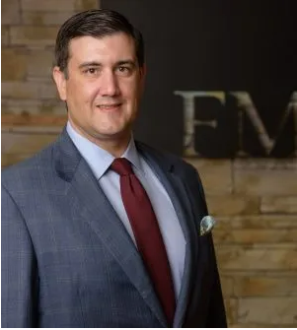
GRAHAM K. SIMMS - “Postproduction Costs”
Graham joined Freeman Mills PC in September 2010, and his practice focuses on litigation, and his practice areas are Oil & Gas litigation and Commercial litigation. Prior to his legal experience Graham was Law Clerk for the Honorable Nancy M. Koenig, U.S. Magistrate Judge and Staff Law Clerk for the U.S. Court of Appeals for the Eleventh Circuit. Graham received his B.S., Civil Engineering, from The University of Texas at Austin and was a Staff Member, for The Review of Litigation

PANEL SPEAKERS – “Lease Provisions”
AMY HOPMANN is Vice President Land Outsourcing with PakEnergy, formerly Land Information Services. She began her career at Mustang Fuel and then moved to Chesapeake Energy prior to LIS
Amy became an active member of OCAPLTA & NALTA, in 2001 and has since served in many capacities. Amy has previously served OCAPLTA as 1st Vice President in 2011 as the Education Chairman and was elected as President of OCAPLTA in 2012 & 2013. She also held positions as Past President/Board Advisor, NALTA Liaison for OCAPLTA and CPLTA Liaison.
She has served on the national board / committees for many years. As NALTA Conference as Exhibitor Chairman in 2003, 2004 and 2005; as the Entertainment Chairman for the 2012 NALTA Conference in Baltimore, MD; and as NALTA Site Selection Co-Chairman for many years. In 2016 she served as NALTA 1st Vice President & Conference Chairman for the 2016 conference in Atlanta, GA. And as NALTA President for 2016-2017. She served as Hotel Chair and Parliamentarian in 2019 for NALTA. And most recently as Entertainment Chair for the 2021 NALTA Conference in Bellevue WA
Amy is also leading the PakEnergy efforts as a Community Business Partner with Oklahoma ReMerge. ReMerge helps restore a pathway for mothers to be restored to the community rather than incarcerated and separated from their families.

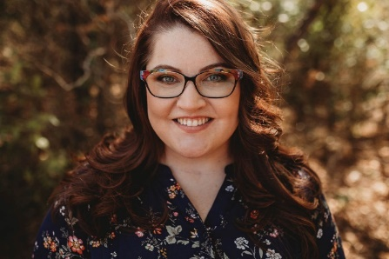
MICHELLE BRADSHAW, CPLTA, serves as the Lease Analyst Lead with Maverick Natural Resources. She is a highly organized and self-driven individual who is proud of her personal achievements, specifically obtaining her CPLTA in 2018 and achieving her Master of Business Administration (4.0 GPA) and Bachelor of Business Management (4.0 GPA) from LeTourneau University in Longview, Texas.
Her 14-year Oil & Gas career began at Tanos Exploration, LLC in Tyler, Texas, where she started as an A/P and Production Clerk, which opened the door to a Lease Analyst position. Finding she enjoyed the challenge, she continued this career path with Vernon E. Faulconer, Eland Energy, and currently Maverick Natural Resources.
She has served in multiple board positions for both the Association of Desk and Derrick Clubs and the East Texas Association of Lease and Title Analysts, including Secretary, Treasurer, Vice-President, and Region IV General Arrangements Chairman. She also served as the 2018 and 2019 Corresponding Secretary for DFW-ALTA and earned the 2019 DFW-ALTA Volunteer of the Year Award.
When Michelle is not working, she lives in Crandall, Texas and spends her time trying to master the Peloton bike, debating just about anything with her husband, chasing five precocious dogs around the backyard, caring for her 93-year-old firecracker of a grandmother, and watching as many true crime documentaries as possible!

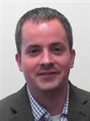
SCOTT DAVIS works as a Senior Staff Land Analyst at Devon Energy in Mid Continent Business Unit. Prior to joining Devon, Scott worked for several different land brokerages holding various positions since 2006. Scott has experience in every major shale play from Utica and Marcellus to Monterey Shale either running title or overseeing data conversions and lease records projects. Scott obtained his CPLTA in 2013. Scott has a degree in Management Information Systems from the University of Central Oklahoma and MBA from Oklahoma Christian University. Scott is an active member in the OCAPL, AAPL, NALTA, and OCAPLTA. Scott was the 2017 OCAPLTA Treasurer, 2019 and 2020 OCAPLTA Liaison to NALTA, 2020-2023 NALTA Recording Secretary, and is an instructor for the CPLTA Review course. He also served as the 2022 NALTA Conference Education Committee Co-Chair. Scott enjoys spending time with his family and friends, traveling, hiking, and flying.

